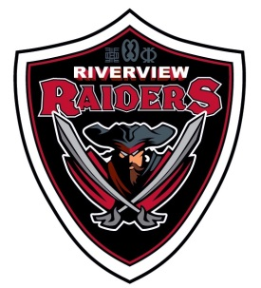
RIVERVIEW MIDDLE SCHOOL
Black Gold Regional Schools
165 Athabasca Drive, Devon, Alberta T9G 1A5
Telephone (780) 987-2204 Fax (780) 987-3542
www.devonrms.ca

Harv Boschman – Principal Richard Dechaine – Assistant Principal

Once a Raider… Always a Raider

Dear Parent(s) Guardian(s) of Health 8 students:

Mr. Haugjord and Mr. Spencer will be teaching the Human Sexuality strand of the Health 8 Program of Studies to your son/daughter between May 25 and June19, 2015. The Alberta program of studies for Health 8 is intended to help students to:

- recognize and accept that individuals experience different rates of physical, emotional, sexual and social development
- determine the signs, methods and consequences of various types of abuse; e.g., neglect, physical, emotional, sexual abuse
- identify and describe the responsibilities and consequences associated with involvement in a sexual relationship
- describe symptoms, effects, treatments and prevention for common sexually transmitted diseases
- identify and describe basic types of contraceptives; e.g., abstinence, condom, birth control pills

If you choose to opt out, your child will be given work to do during this period outside of the classroom. Our young people are confronted daily with an array of information through friends, peers, media, and it is this unit’s intention to try to make it less confusing and conflicting for them. Your input into this area is most valuable.

Please feel to contact the school at 780-987-2204 if you should have any questions or concerns.

Please indicate below if you want your child to participate. Your child must return a signed form to participate in the program.

Thank you,

Mr. Haugjord and Mr. Spencer

I give my child permission to participate in the Human Sexuality portion of the Health 8 Program.

_________________________ _______________________
Student’s Name Date

_________________________
Parent/Guardian signature

