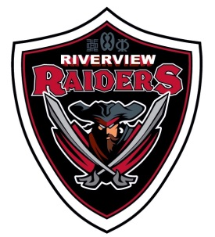
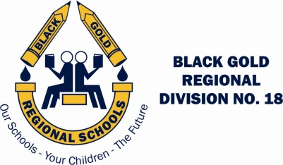
RIVERVIEW MIDDLE SCHOOL
Black Gold Regional Schools
165 Athabasca Drive, Devon, Alberta T9G 1A5
Telephone (780) 987-2204 Fax (780) 987-3542
www.devonrms.ca

Harv Boschman – Principal Richard Dechaine – Assistant Principal

Once a Raider… Always a Raider

Dear Parent(s) Guardian(s) of Health 9 students:

Mr. Spencer will be teaching the Human Sexuality strand of the Health Program to your son/daughter on between May 25 and June 19, 2015. The Alberta program of studies for Health 9 is intended to help students to:

- apply coping strategies when experiencing different rates of physical, emotional, sexual and social development; e.g., positive self-talk
- evaluate implications and consequences of sexual assault on a victim and those associated with that victim
- determine “safer” sex practices; e.g., communicate with partner, maintain abstinence, limit partners, access/use condoms/ contraceptives properly
- identify and describe the responsibilities and resources associated with pregnancy and parenting
- develop strategies that address factors to prevent or reduce sexual risk; e.g., abstain from drugs and alcohol, date in groups, use assertive behavior
If you choose to opt out, your child will be given work to do during this period outside of the classroom. Our young people are confronted daily with an array of information through friends, peers, media, and it is this unit’s intention to try to make it less confusing and conflicting for them. Your input into this area is most valuable.

Please feel to contact the school at 780-987-2204 if you should have any questions or concerns.
Please indicate below if you want your child to participate. Your child must return a signed form to participate in the program.

Thank you,

Mr. Spencer

I give my child permission to participate in the Human Sexuality portion of the Health 9 Program.

_________________________ _______________________
Student’s Name Date

_________________________
Parent/Guardian signature

