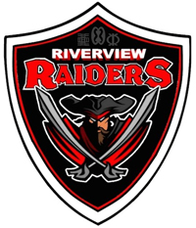
RIVERVIEW MIDDLE SCHOOL
Black Gold Regional School
165 Athabasca Drive, Devon, Alberta T9G 1A5
Telephone (780) 987-2204 Fax (780) 987-3542
www.devonrms.ca

Brian Scott - Principal Richard Dechaine –Assistant-Principal

Once A Raider, Always a Raider

________________________________________________________________________________

May 22, 2018

Dear Parents and Guardians,

This is a reminder that on Friday, May 25, the Grade 5 classes will be going to Miquelon Lake Provincial Park – Park Centre, to participate in a Wetlands Field Study. This study will be presented by the Parks and Protected Areas Division.

Specific program objectives include identifying plants and animals found at a wetland site, describing the life cycles of these plants and animals, and identifying the role of different organisms in the food web that exist in pond ecosystems.

Please make sure that your child is dressed appropriately for the weather as these activities will take place outdoors. Students should wear a hat, long pants, and bring rubber boots or old running shoes. An extra pair of socks and shoes should also be brought so students may change footwear if needed. Bug spray, sunscreen, and rain gear are encouraged.

As we will be away for the day, please ensure your child has a lunch, snacks, and water bottle. There are no microwaves available for lunch.

If you have any questions, please feel free to contact the school at 987-2204.

Thank you,

Mr. D. Spencer

