Grade 8
English Language Arts
Part B: Reading

Review Guide

Name: _________________
Overview
Test Date: Wednesday, June 25 at 9:00 am
The test will contain 90 multiple-choice questions
This test was developed to be completed in 1 hour 45 minutes
You may NOT use a dictionary, a thesaurus, or other reference materials
The readings will include the following types of texts:
- Informative (articles and comics)
- Narrative (short stories, scripts, novel excerpts)
- Poetic (poems and lyrics)
The following pages contain review notes.

What to Study
You should be familiar with the terms listed below that were discussed in our units. For each term you need to understand it and identify examples of it in a text.
Parts of Speech & Grammar:
- Simple sentence
- Compound sentence
- Complex sentence

- Independent clause
- Dependent clause

- Comma
- Colon
- Dash
- Semi-colon

- Comma splice
- Sentence fragment
- Run-on sentence

- Noun
- Adjective
- Verb
- Adverb
- Pronoun
- Synonym

Essay Writing:
- Thesis Statement
- Body Paragraph

Reading (Short Stories & Poetry):
- Conflict
- Protagonist
- Antagonist
- Theme
- Point of View (narration)
  - First Person
  - Third Person Limited
  - Third Person Omniscient
- Irony
  - Verbal
  - Dramatic
  - Situational
- Foreshadowing
- Imagery
- Simile
- Metaphor
- Plot Structure
  - Exposition
  - Rising Action
  - Climax
  - Falling Action
  - Resolution
- Vocabulary
  - Context clues
- Alliteration
- Assonance
- Rhyme Scheme
- Personification
- Onomatopoeia
- Hyperbole
- Oxymoron
- Stanza
Short Story Study Notes
Character
- Protagonist
- Main character of the story that changes (The most important character)
- changes and grows because of experiences in the story
- Antagonist
- A major character who opposes the protagonist
- Types of antagonists:
  - people
  - nature
  - society
Conflict
- A struggle between two opposing forces
- Types
  - Internal – takes place in a character’s own mind
    - Man vs. Him(Her)self
  - External – a character struggles against an outside force
    - Man vs. Man
    - Man vs. Nature
    - Man vs. technology, progress
    - Man vs. Society
    - Man vs. Supernatural

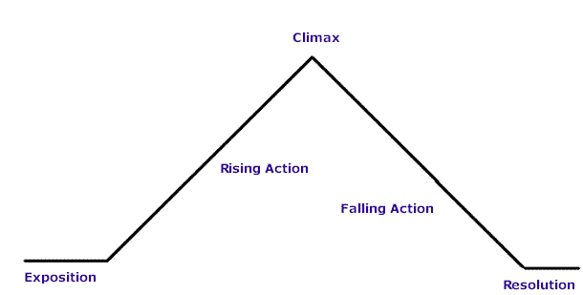
Plot
- Plot: Series of related events that make up a story.
Exposition
  - Section that introduces characters, the setting, and conflicts.
Setting
  - The time and place of the story’s action
Rising Action
  - Consists of a series of complications.
  - These occur when the main characters take action to resolve their problems and are met with further problems:
    - Fear
    - Hostility
    - Threatening situation
Climax
  - The turning point in the story: the high point of interest and suspense
Falling Action
  - All events following the climax or turning point in the story. These events are a result of the action taken at the climax.
Resolution
  - The end of the central conflict: it shows how the situation turns out and ties up loose ends
Point of View
- Vantage point from which the writer tells the story.
  - First person- One of the characters is actually telling the story using the pronoun “I”
  - Third person limited- Centers on one character’s thoughts and actions.
  - Third person omniscient- All knowing narrator. Can center on the thoughts any actions of any and all characters.
Irony
- A contrast between expectation and reality
- Verbal Irony – saying one thing but meaning something completely different.
- Situational Irony – A contradiction between what we expect to happen and what really does happen
- Dramatic Irony – occurs when the reader knows something important that the characters in the story do not know.
Theme
- The central message or insight into life revealed through a literary work.
- The “main idea” of the story
- Theme: Life lesson, meaning, moral, or message about life or human nature that is communicated by a literary work.
- In other words…Theme is what the story teaches readers.
- Examples of theme:
  - Money can’t buy happiness.
  - Don’t judge people based on the surface.
  - It is better to die free than live under tyranny.
- Themes are not explicit (clearly stated).
- Themes are implied (you have to read the story, look for looks, and determine the theme).
Foreshadowing
- Clues the writer puts in the story to give the reader a hint of what is to come.
Symbol
- An object, person, or event that functions as itself, but also stands for something more than itself.
- Symbolism can be found in colors:
  - Black is used to represent death or evil.
  - White stands for life and purity.
  - Red can symbolize blood, passion, danger, or immoral character.
- Objects are often used to symbolize something else
  - Dove = Peace, Rainbow = Hope, Mountain = Obstacles/Adversity
- Symbols used in literature are objects used to represent other things or ideas
- In literature, symbolism is used to provide meaning to the writing beyond what is actually being described.
- The plot and action that take place in a story can be thought of as one level, while the symbolism of certain things in the writing act on another level to enhance the story.
Figurative Language
- Involves some imaginative comparison between two unlike things.
- Simile – comparing two unlike things using like or as.
  - “I wandered lonely as a cloud”

- Metaphor – comparing two unlike things (not using like or as)
  - Life is a roller coaster, it has lots of ups and downs.
- Personification – Giving human qualities to non-human things.
  - “The wind howled”
Suspense
- Uncertainty or anxiety the reader feels about what is going to happen next in a story.
Imagery
- Language that appeals to the senses.

  - Touch
  - Taste
  - Sight
  - Sound
  - Smell

Poetry Study Notes
Alliteration
- The repetition of the first consonant sound in a word.
  - Peter Piper picked a peck of pickled peppers.
Assonance
- The repetition of vowel sounds in a series of words.
  - The fat cat was wearing a miniature hat as he lay down on the mat.
Rhyme
- The repetition of ending sounds in words.
  - Thad was a very sad lad.
Rhyme Scheme
- A rhyme scheme is a pattern of rhyme (usually end rhyme, but not always).
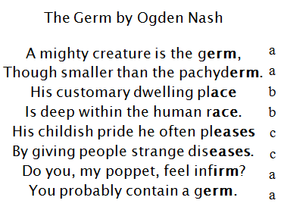
- Uses the letters of the alphabet to represent sounds to be able to visually “see” the pattern.
Onomatopoeia
- The use of words which imitate sound.
  - Thud! Boom! Crack! Buzz!
Simile
- A comparison between two objects using "like", "as", or "than”.
Metaphor
- A comparison between two dissimilar objects. Usually the words “is”, “are”, or “was” are used.
  - For me time is money.
Personification
- Giving inanimate or non-living objects human characteristics.
  - The trees danced in the wind.
    - Write a sentence using personification.
Hyperbole
- A hyperbole is an exaggeration or overstatement. It is often meant to be humorous.
  - He inhaled the sandwich.
  - I have a million things to do.
Oxymoron
- A figure of speech that combines two words with opposite meanings.
  - Jumbo shrimp, act naturally, calm storm, cold sweat, good grief
Stanza
- a group of lines separated from other lines by breaks in the poem. Similar to a paragraph.

Context Clues
- When you come across a word you don't know, don’t stop reading.
- You can often figure out the meaning of an unfamiliar word by using the words around it. The surrounding sentence or paragraph is known as the context.
Here's an example: Sue's boss was a callous man. He did not react to her tears and apologies.
- From the context you know that a callous man does not react to tears and apologies. Callous means “hard-hearted” or "insensitive to emotion."
Synonym
- A Synonym is a word that has almost the same meaning as another word.
- For example, a synonym for beautiful is stunning:
  - She is a beautiful girl.
  - She is a stunning girl.

Parts of Speech & Grammar
Simple Sentence
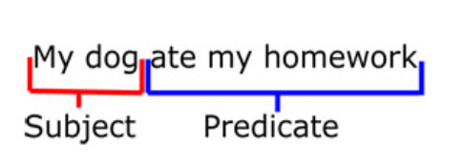
- Contain a subject and a predicate
- Express a complete thought
  - The subject is the actor.
  - A Predicate modifies the subject of a
sentence.
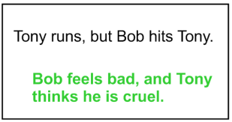
Compound Sentence
- Contain two independent clauses.
- Like a simple sentence sandwich.
- Coordinate conjunctions are used to join independent clauses in compound sentences.
  - For, and , nor, but, or, yet, so

Complex Sentence
- Consists of one or more independent clause and one or more subordinate clauses.
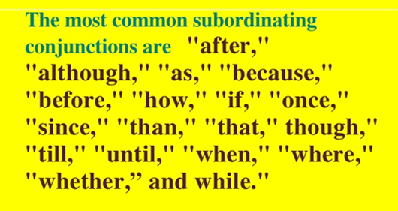

Independent Clause
- A clause that can stand alone as a sentence (i.e., it expresses a complete thought).
- An independent clause, like all clauses, has a subject and verb.
  - Here is an example of an independent clause (shaded). Notice how it could stand alone as a sentence.
  - I have enough money to last me the rest of my life, unless I buy something.

Dependent Clause
- A dependent clause (or subordinate clause) is one that cannot stand alone as a complete sentence, because it does not express a complete thought.
- Like all clauses, a dependent clause has a subject and verb.
  - Here is an example of a dependent clause (shaded). Notice how the shaded clause could not stand alone as a sentence.
  - The crew could see the whale, which had surfaced only 50m behind them.
Comma
- The comma serves several purposes:
1. Commas separate items in a series. Example: He went to the park with Dan, his cousin, and his friend.
2. In compound sentences use a comma before the conjunction. Example: He performed the routine flawlessly, and the judges rewarded him with a perfect score.
3. Use a comma in complex sentences after the introductory subordinate clause. Example: When the photographer took the picture, she knew exactly how it would turn out.
4. Separating items in dates and addresses. Example : Monday, September 24, 2012. Example : 165 Athabasca Drive, Devon, Alberta.
5. Commas can punctuate interrupters. An interrupter is a word, phrase, or clause that significantly breaks the flow of a sentence.
Colon
- Starts a list
  - We need these things: paper, pencils, erasers, pens, and glue.
- Precedes a formal quotation
  - Hemingway said: “There is no friend more loyal than a book.”
- Separates hours and minutes
  - The time is 7:45 A.M.
Semi-Colon
- Connects to main clauses where a conjunction is not used:
- Cody worked at A & W; he was dismissed.
- Separates items in a list that contains other punctuation:
- I have lived in Devon, Alberta; Kalispell, Montana; and Victoria, British Columbia.

Hyphens (dashes)
- Divide words at the end of text or indicate compound adjectives before a noun.

Sentence Fragment
- A sentence should have a subject, a verb and express a complete thought. If it fails to do so, then it is a sentence fragment.
- A sentence fragment is a sentence that:
  - Does not express a complete thought - Example: Joe is.
  - Is lacking a subject - Example: Eating chicken.
  - Is lacking an action - Example: A book without a cover.
  - Is a dependent clause, standing alone - Example: When I went to the store.
Run-on Sentences
- A run-on sentence is a sentence in which two or more independent clauses (sentences that
could stand on their own) are joined together improperly.
- For example:
  - I went to the store I got milk and cookies.
Comma Splice
- When two independent clauses are connected by only a comma, they constitute a run-on sentence that is called a comma-splice.
Noun
- A noun refers to a person, place, or thing—such as an object, concept, idea, or event.
Adjective
- An adjective is a word that modifies a noun or a pronoun. It can describe, limit, or identify the noun or pronoun.
  - Example: She likes oatmeal cookies
- A descriptive adjective adds details and answers the question, What is it like/
  - Example: fresh vegetables, white cat
Verb
- Verbs are words or nouns that express an action, or state of being
Adverb
- An adverb is a word that modifies a verb, an adjective, or another adverb.
- An adverb usually tells: how, when, where, to what extent, or how often.
- Many adverbs end in “ly”
  - Example: “No,” George said stubbornly.
Pronoun
- A pronoun takes the place of one or more nouns or a group of words in a sentence.

Essay Writing

Thesis Statement
- A thesis statement is a complete sentence that contains one main idea.
- This idea controls the content of the entire essay.
- A thesis statement that contains subpoints also helps a reader know how the essay will be organized.

Body Paragraph
- The body paragraphs in an essay support the main idea in the thesis statement by breaking it down into smaller ideas or subtopics.
- Ideas in the body paragraphs should relate back to the thesis statement.

