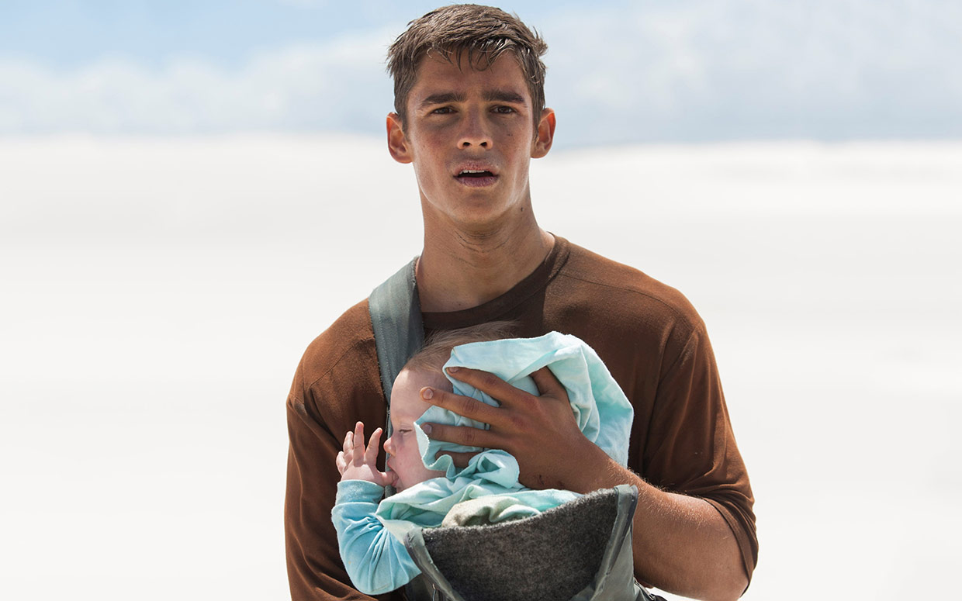
The Giver: Chapters 20-23
Discussion Questions
Individuality and Freedom of Choice
- Analyze the advantages and disadvantages of Sameness in Jonas' community.
- The people in Jonas' community gave up their freedom and individuality to live in a safe environment. Discuss whether or not the community is a safe environment in which to live. How would you define what a safe environment is?
Unanswered Questions
- What questions did the author leave unanswered at the end of the book?
- How did you interpret the end of this book? How do you think the story ends?

Personal Response Questions: Chapters 20-23

Chapter 20

- What do you think The Giver means when he says, “They know nothing”? Do you agree? Explain.
_____________________________________________________________________________________________________________________________________________________________________________________________________________________________________________________________________
- Do you agree now with the statement that “memories need to be shared”? Explain why you do or do not?
_____________________________________________________________________________________________________________________________________________________________________________________________________________________________________________________________________
- How did The Giver and Jonas plan to change the society in the book?
_____________________________________________________________________________________________________________________________________________________________________________________________________________________________________________________________________

Chapter 21

- Why does Jonas feel that he must leave earlier than planned?
_____________________________________________________________________________________________________________________________________________________________________________________________________________________________________________________________________
- How do you feel about Father when he is so calm and sweet when he talks about Gabe’s release?
_____________________________________________________________________________________________________________________________________________________________________________________________________________________________________________________________________
- What would have happened to Jonas and Gabe if the searchers caught them? Explain your answer.
_____________________________________________________________________________________________________________________________________________________________________________________________________________________________________________________________________

Chapter 22

- If Jonas and Gabriel starve, will their efforts have been worth it in your opinion? Explain your thinking.
_____________________________________________________________________________________________________________________________________________________________________________________________________________________________________________________________________

- Why does the book say, “he had made the wrong choice” and a few lines later say “there had not really been a choice”? How might you explain these contradictory statements?
____________________________________________________________________________________________________________________________________________________________________________________________________________________________________________________________________
- What could have brought Jonas to the point where he could cry for Gabriel but not for himself?
_____________________________________________________________________________________________________________________________________________________________________________________________________________________________________________________________________

Chapter 23

- How does the content of Jonas’s memories change as he approaches the summit of the hill?’
_____________________________________________________________________________________________________________________________________________________________________________________________________________________________________________________________________
- What does it mean that Jonas found a memory of his own?
_____________________________________________________________________________________________________________________________________________________________________________________________________________________________________________________________________
- How do Jonas and Gabe finally get to safety?
_____________________________________________________________________________________________________________________________________________________________________________________________________________________________________________________________________
