Computers 5
Course Outline 2014-2015
Instructor: Mr. Spencer

Welcome to Computers 5. Our goal in computers 5 is to enhance present computing skills and develop new strategies for getting the most out of the technology in our lives.

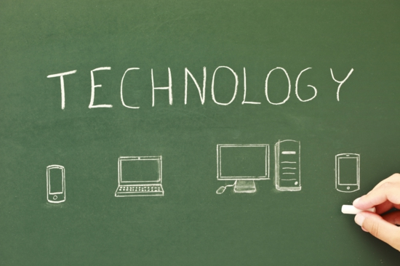
Attitude: Students will encounter many new products, programs, and tools in this course. We will work together to learn to manage these resources and develop the personal skills necessary to use them effectively. This will require real work, study, and a positive attitude from everyone. Respect for all work is expected. Keep all comments constructive and supportive.

Behavior: Students are expected to:
- Respect the work and ideas of others.
- Work within your own space
- Care for netbooks and technology

Outcomes:

C.1 -7 Students will access, use and communicate information from a variety of technologies. Students will seek alternative viewpoints, using information technologies. Students will critically assess information accessed through the use of a variety of technologies. Students will use organizational processes and tools to manage inquiry. Students will use technology to aid collaboration during inquiry. Students will use technology to investigate and/or solve problems. Students will use electronic research techniques to construct personal knowledge and meaning.

F.1 -6 Students will demonstrate an understanding of the nature of technology. Students will understand the role of technology as it applies to self, work and society. Students will demonstrate a moral and ethical approach to the use of technology. Students will become discerning consumers of mass media and electronic information. Students will practice the concepts of ergonomics and safety when using technology. Students will demonstrate a basic understanding of the operating skills required in a variety of technologies.

P.1 -6 Students will compose, revise and edit text. Students will organize and manipulate data. Students will communicate through multimedia. Students will integrate various applications. Students will navigate and create hyperlinked resources. Students will use communication technology to interact with others.

Course Materials
- Students may access their course material using their Blackgold server accounts as well as gshare accounts and applications.
- Keyboarding will be supported using Typingweb. Students will have access to their folders and apps through any web browser at home, but google chrome will be an asset. This is a free download.
- The class website is accessible at https://sites.google.com/a/gshare.blackgold.ca/mr-spencer-s-home/computers-5

Units:

Unit 1: Servers, programs, and cloud based systems.
Students will access, use and communicate information from a variety of technologies.
Students will demonstrate an understanding of the nature of technology. Students will understand the role of technology as it applies to self, work and society Students will integrate various applications. Students will use organizational processes and tools to manage inquiry.

Unit 2: Research and presentations
Students will critically assess information accessed through the use of a variety of technologies.
Students will use technology to investigate and/or solve problems. Students will use electronic research techniques to construct personal knowledge and meaning. Students will become discerning consumers of mass media and electronic information.

Unit 3: Web publishing and net safety
Students will demonstrate a moral and ethical approach to the use of technology.
Students will practice the concepts of ergonomics and safety when using technology.
Students will compose, revise and edit text. Students will navigate and create hyperlinked resources.

Unit 4: Communication technology
Students will access, use and communicate information from a variety of technologies. Students will seek alternative viewpoints, using information technologies. Students will demonstrate a basic understanding of the operating skills required in a variety of technologies. Students will integrate various applications. Students will navigate and create hyperlinked resources. Students will use communication technology to interact with others.

Unit 5: Organization and data
Students will compose, revise and edit text. Students will organize and manipulate data.
Students will demonstrate a basic understanding of the operating skills required in a variety of technologies. Students will integrate various applications. Students will use organizational processes and tools to manage inquiry.

Course Evaluation:
Assignment portfolio: 80%
Keyboarding: 20%

Students will be graded on a variety of assignments. All assignments are given an equal weighting.

