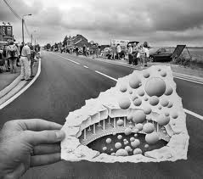Drawing 7/8/9

Course Outline 2014-2015

Instructor: Mr. Spencer

Welcome to Drawing7/8/9. This course has been designed to help you see, interpret, and make sense of visual material.

**Attitude:** This program’s focus is to help students develop an appreciation for all works of art, including their own. Respect for all work is expected. Keep all comments constructive and supportive.

|  |
| --- |
| **Behavior:** Students are expected to:   * Respect the work and ideas of others. * Work within your own space * Clean up their area and common areas * Bring a pencil * Care for the tools and materials in the art lab |

**Modules:**

In Drawing 789 you will explore modules that explore different drawing techniques, tools, and principles of design. We will attempt to complete 3 modules this term. Modules have more than one component and may require the submission of a number of works for assessment. You will also have some choice within the modules as to the direction that your artwork will take.

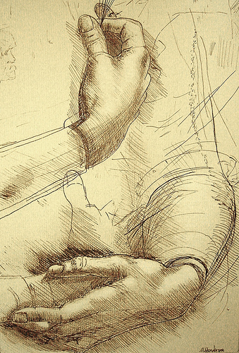

**Modules:**

701- Line- Internal and External Boundaries

702- Movement and Recording Change

705- Planes and Volume

801- Basic Shapes

802- Perspective

803- Transformations

804- Principles of repetition and emphasis

901- Surface and Volume

903- Illusion of Depth

907- Positive and Negative Space

909- Principles of balance, contrast, repetition, and point of view

**Course Evaluation:**

Each module will be assessed on several criteria. Students will have the opportunity to assess their own work prior to submission using the same scoring rubric. All modules are due on a specific class period and must be complete at this time. Students may upgrade their module within 5 days of receiving it back. This can be done after school or at lunch if arrangements are made with their instructor.

**Safety:**

You are more than welcome to prepare your work space and continue working on your modules as soon as you enter the classroom. **Do not use any materials or tools that you have not been instructed how to use it safely.** Should you desire a unique tool or material, please ask your instructor as some items may not be safe if used incorrectly.