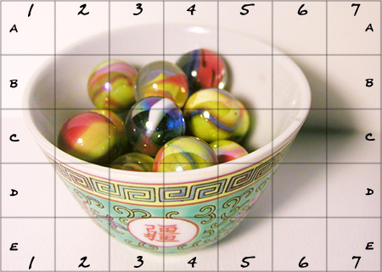

Drawing for photo realism
Step 1. Marble bowl
This one is our practice project. You will complete these same steps for an object of your own choosing in step 2.
Trace a 5x7 grid onto a piece of drawing paper. Each square should be 1" x 1"
In each square, copy the value, line, and shape that you observe. Work with one square at a time and try to get it as close to the original as possible.
Remove the lines and numbers. Mount your finished drawing.

Step 2: Your own object
Search the internet for an object or photograph one of your own. Object should have strong contrast and multiple shades. Don't worry if it is black and white or color. They will all be black and white once printed.
Copy the image into word or google docs.
Using a ruler, copy a 5x7 grid onto the image. you do not need to worry about size as this can be enlarged to fit your page when done. Just make sure the grid squares are all the same size.
Again, copy the 5x7 grid onto a piece of grid paper.

