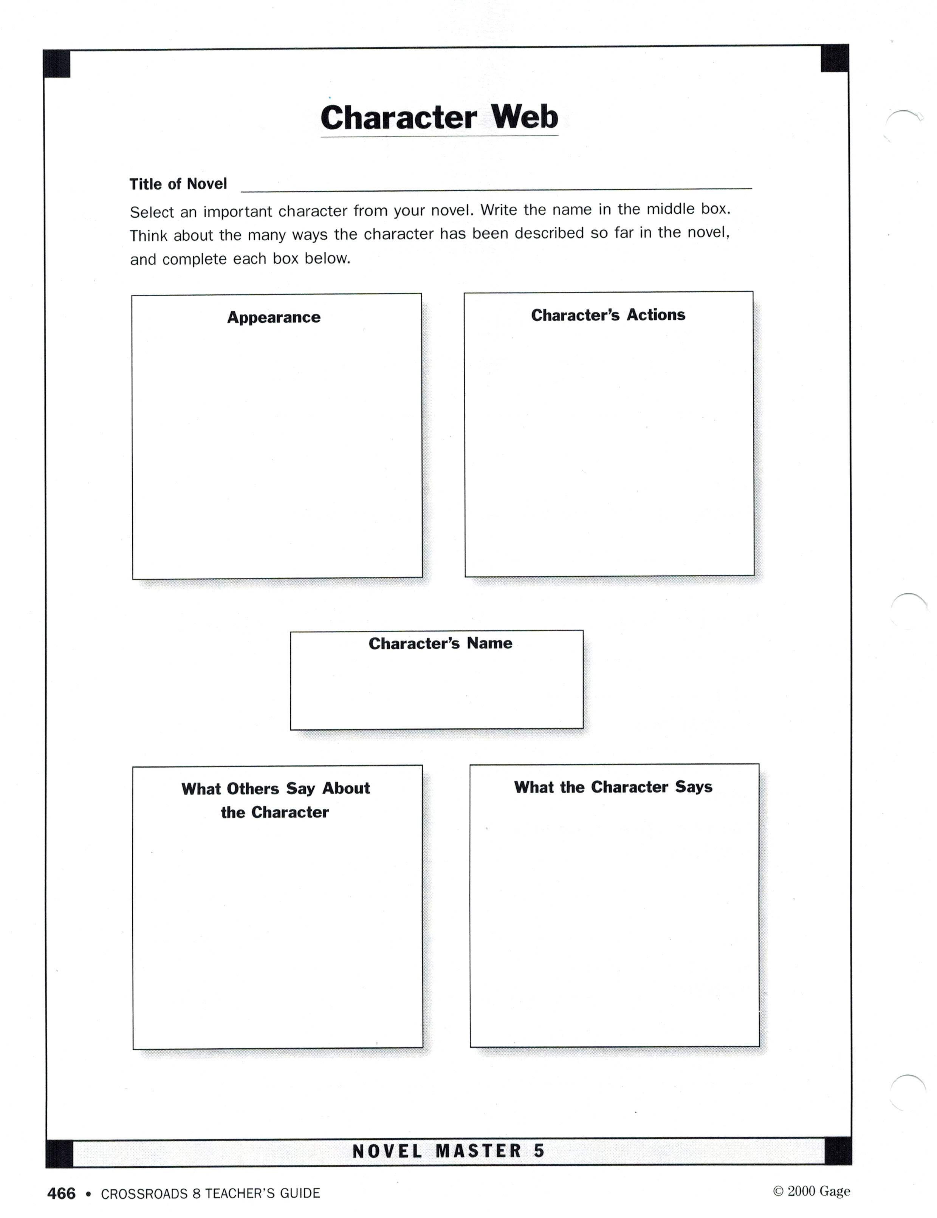
Chapter 2 Literal Questions:
- The chapter begins with a descriptive paragraph. List the descriptive words in this beginning paragraph.

- How does David Feel about people?

- Why is David feeling different about life now?

- Where does he stay to hide from people?

- What thought frustrates David and causes him to lose hope?

- Which foreign languages can David understand?

- Which two things worry David the most?

- What building does David discover and visit every evening in town?

- Why does David pick up a newspaper?

- What is peculiar about David’s eyes according to people who meet him?

I am David Chapter 2 Critical Response Questions
Complete the following questions on a separate page. Use complete sentences and be sure to defend your responses with specific references to the text.
- David gives himself a good scrubbing but he is doing more than just taking a bath. What is symbolic about David’s use of the soap to clean his self? Why do you feel this action is so important to him?

- What effect does David’s cleansing himself have on the way he sees his surroundings? Identify one sentence, or group of sentences from the novel that shows David has changed in this chapter. Explain what the change is after your quotation.

- Once David has found his hiding place he makes a list of his strengths and weaknesses. What strengths and weaknesses does he identify?

- When visiting the town, David is made aware of how others see him. How do other characters describe David? What inferences can you make based on these descriptions?

- What makes David leave town? Do you feel this was a wise decision? Explain.

- Do you think David is a normal child? What child-like traits does he possess? What child-like traits are absent from his character?

