Fire Ants Could Inspire the Next Rescue Robots
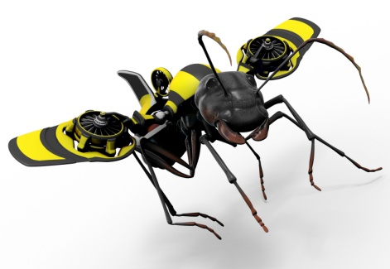
Read the article and respond to the questions below.
1. What is the main idea of the article?

2. Who is quoted directly in the article? Why do you think these people were chosen?

3. Is this fiction or non-fiction writing? Explain why you think so.

This is probably the first study to really detail-out the features of moving in confined environments," Gravish says. "It's so different from traditional biomechanics studies of running and climbing, where you're watching animals move around in a featureless environment."
4."What does the speaker above believe traditional studies of biomechanics are like?

Future rescue robots will almost certainly utilize legs, although robotic legs raise significant biomechanical and computing challenges in robotics today. Added appendages add more complexity.
5. What does “utilize” mean in the above context?

"We haven't really used them in search and rescue yet. But using the environment makes it more practical and much more likely . . . I think that with a concerted effort you could see prototypes as early as five years from now."
6. What does “concerted effort” mean in the above context?

7. In your opinion, do robots make good rescue workers? Give reasons for your response.
“The Iron-Barred Door”
Pre-reading
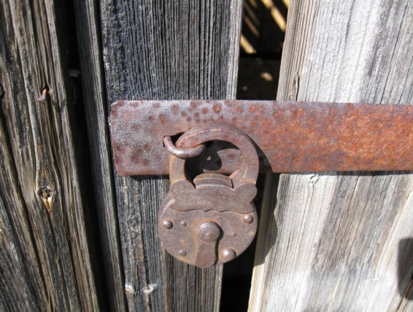
Defining these words will aid with comprehension of the story. Complete the following on loose-leaf for each of the following words:
a) define the word
b) use the word correctly in a sentence
c) draw a picture or icon to represent the word means
1. rubble
2. charred
3. cloisters
4. mantel
5. parquet
6. vista
Literal Questions:
1. Describe the setting of the story. Include physical and chronological setting descriptions.
________________________________________________________________________________________________________________________________________________________________________________________________________________________________________________________________________________________

2. There are two characters in the story. Describe them.
________________________________________________________________________________________________________________________________________________________________________________________________________________________________________________________________________________________

3. Whose point of view is the story told from? Give evidence for this. How do you know?
________________________________________________________________________________________________________________________________________________________________________________________________________________________________________________________________________________________

4. Is this 1st, 2nd, or 3rd person narration? Explain why.
____________________________________________________________________________________________________________________________________________

Inferential:
5. The conflict in this story is not entirely external. Rebecca is safe within her house, but she does struggle against something. Describe the conflict that Rebecca wrestles with and eventually confronts.
________________________________________________________________________________________________________________________________________________________________________________________________________________________________________________________________________________________

6. The barred door in the title is symbolic in this story. What does the barred door represent for Rebecca?
________________________________________________________________________________________________________________________________________________________________________________________________________________________________________________________________________________________

Critical
- What do you think had happened to the city?
______________________________________________________________________________
______________________________________________________________________________
______________________________________________________________________________

2. Why do you think Rebecca and George survived?
______________________________________________________________________________
______________________________________________________________________________
______________________________________________________________________________

3. What might have happened to Rebecca's parents?
______________________________________________________________________________
______________________________________________________________________________
______________________________________________________________________________

4. Why do you think the door is bolted?
______________________________________________________________________________
______________________________________________________________________________
______________________________________________________________________________

Create a venn diagram that compares the non-fiction science article “Fire Ants Could Inspire the Next Rescue Robots” and the story “The Iron-Barred Door”.

Rubric for Venn Diagram | Content | Format
5  Standard of Excellence | * identifies many attributes  that two concepts or ideas  share  * identifies and records  many ways that concepts  or ideas are different  * uses precise, detailed  vocabulary to describe  attributes and includes  descriptive detail to  compare and contrast | * clearly and creatively  labels all parts of the diagram  * descriptive and attention-getting  title  * sub-headings are used so that  like information is compared and  contrasted in corresponding  sections of the chart: information  or ideas contain interesting detail
4  Exceeds Acceptable Standard | * identifies several attributes  that two concepts or ideas  share  * identifies and records several  ways that concepts or ideas are  different  * uses specific vocabulary to  describe attributes | * clearly labels all parts  of the diagram  * descriptive title  * sub-headings are used  so that like information is  compared and contrasted in  corresponding sections  of the chart; information  or ideas contain interesting detail
3  Meets Acceptable Standard | * identifies some attributes that  two concepts or ideas share  * identifies and records some  ways that concepts or ideas are  different  * uses appropriate vocabulary  to describe attributes | * clearly labels the main  parts of the diagram  * appropriate title  * information is organized  so that like information is  compared in corresponding  sections of the chart; information  or ideas contain essential detail
1-2  Needs Improvement to  Meet Acceptable Standard | * identifies few commonalities  and differences  * common attributes  identified  * uses vocabulary that may  contain vague generalities;  lack detail | * labels some parts of the diagram  * title that is vague or  inappropriate  * information is organized  randomly so like attributes are  not in corresponding sections  of the chart; information or ideas  lack essential detail

