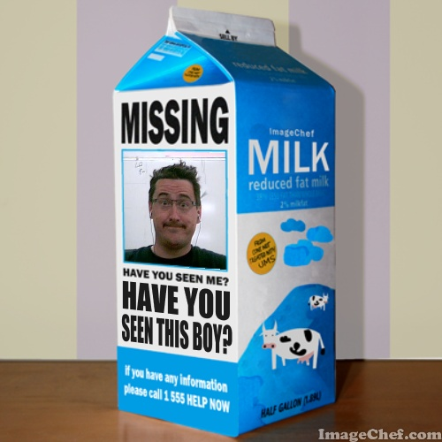
Lost Boy
Key outcomes
- Interpret the choices and motives of characters portrayed in oral, print, and other media texts, and examine how they relate to self and others
- Identify and describe characters’ attributes and motivations, using evidence from the text and personal experiences
In chapter 4, David comes to live with the family of Giovanni di Levana del ‘Varchi. For the first time in his life he is treated to luxuries and the security of a family. Even though he is quite interested in learning about this world, David is torn between a desire to stay and his desire to escape. It is with this family too, that David receives new clothes. As he examines his reflection David remarks, “I look quite like an ordinary boy now, don’t I?”
If the family di Levana del ‘Varchi were to look for David, describe the “Lost Boy” milk carton ad they would create for him. Be sure to include in your description:
- his physical appearance
- his mannerisms (How are they unusual from an average boy?)
- why the family thinks he left (Give specific evidence from the text)
- Identify the del ‘Varchi family’s reasons for wanting him back and who should be contacted if David is found.
Grading criteria

Criteria | 5 | 4 | 3 | 2 | 1
Physical Attributes | The image(s) are a detailed account of David’s physical attributes as shown in chapters 1-5. Image(s) is clear and detailed. | The image(s) includes many of David’s physical attributes as shown in chapters 1-5. Image(s) is clear and detailed. | The image(s) shows a general understanding of David’s physical attributes found in chapters 1-5. | The image(s) show a limited understanding of David’s physical attributes found in chapters 1-5. | The image(s) does not show physical attributes found in chapters 1-5
Mannerisms and motivation | Poster describes or shows:  - The family’s reaction to David’s unusual persona.  -Detailed list of David’s mannerisms and expected behaviors.  - gives detailed reasons behind David’s disappearance and supportive evidence from the text. | Poster describes or shows:  -Clearly how David is expected to act  -Many of David’s mannerisms and expected behaviors.  - gives clear reasons behind David’s disappearance and evidence from the text. | Poster describes or shows :  -How David is expected to act  -Some of David’s mannerisms and expected behaviors.  - gives reasons behind David’s disappearance and vague evidence from the text. | David’s expected behavior and mannerisms are shown or described. Images or descriptions are unclear or incomplete.  -gives general reasons behind David’s disappearance. | Manners and reactions are not clearly portrayed by the wanted poster.
Technique | Exceptional care and detail are shown in the artwork and layout. | Care and detail shown in the artwork and layout is very good. | Good care and effort are shown in the artwork and layout. | Satisfactory care and effort are shown in the artwork and layout. | Little care or effort is shown in the artwork and layout.
Total:______/15

