Writing with Effective Parts of Speech
Name:_______________________________Date:_______________ Class:________
Assignment:
Write an original narrative, 6-10 sentences in length. Use specific and impactful words to create a descriptive narrative of an individual's journey across a busy road. Be sure to give careful consideration pronoun antecedents, verb tense, and effective adverbs and adjectives. Next class, you will exchange your paragraph with one of your classmates, who will proofread your writing and identify parts of speech used to further enhance your writing.
Criteria | You nailed it!  4 | Good effort, just a bit more polishing. 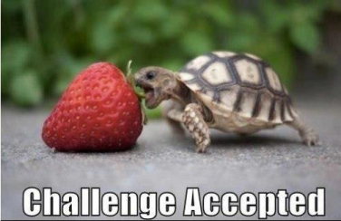  3 | Not quite yet  2 | Insufficient  1-0
Content | Narrative is insightful and original. Purpose is clear and deliberate. Ideas details are precise and carefully chosen. Writing is confident and holds the reader’s interest. | Topic is clear and logical. Purpose is evident. Ideas are appropriate and/or predictable. Details are relevant and/or generic. Writing occasionally appeals to reader’s interest. | Topic is simplistic. Purpose is vague. Ideas are unclear. Supporting details are imprecise or abbreviated. Writing seems uncertain. | Narrative is incomplete or underdeveloped.
Noun Verb Choice | Nouns are precise and accurate. Verbs tense is consistent. Nouns and verbs create clear and vivid images. Voice/tone is convincing. | Nouns are specific. Verb tense rarely shifts. Nouns and verbs create some images related to topic. Voice is discernible but inconsistent. | Nouns are vague and/or inaccurate. Verb tense shifts clouding meaning. Nouns and verbs are ineffective. Voice is unclear. | Nouns and verbs show little consideration and frequent errors.
Adjective Adverb Choice | Adverbs are used frequently to describe and clarify action. Adjectives are frequently used enhances specific details about objects. | Adverbs are used occasionally to describe and clarify action. Adjectives are occasionally used enhances specific details about objects. | Adverbs are used infrequently to describe and clarify action. Adjectives are infrequently used enhances specific details about objects. | Adverbs and adjectives are seldom used. Frequent errors blur clarity.
Conventions  (Spelling, capitalization, punctuation) | Writing is precisely proofread and revised and contains essentially no errors that interrupt the flow or clarity. | Writing is proofread and revised and contains few errors that blur clarity or interrupt the flow. | Writing is carelessly proofread and contains errors that blur meaning and interrupt flow. | The writing is impaired by errors. Clarity is severely reduced by mechanical errors.

Total:_____ / 16

