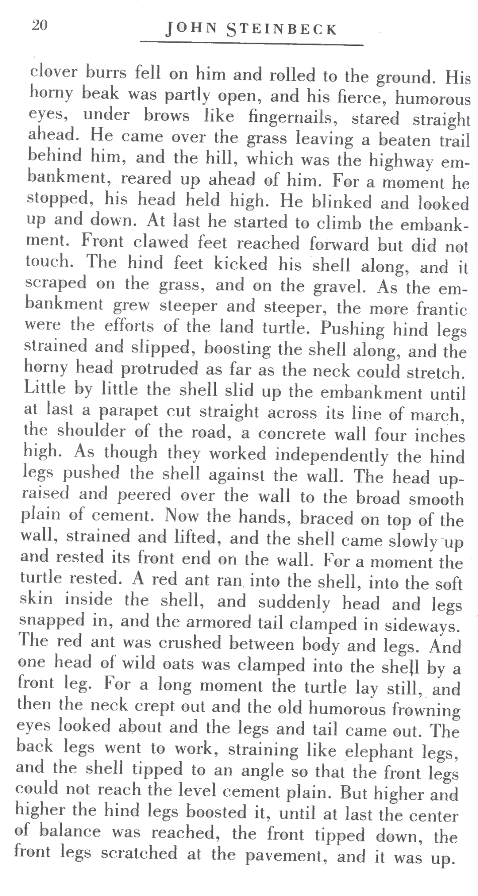
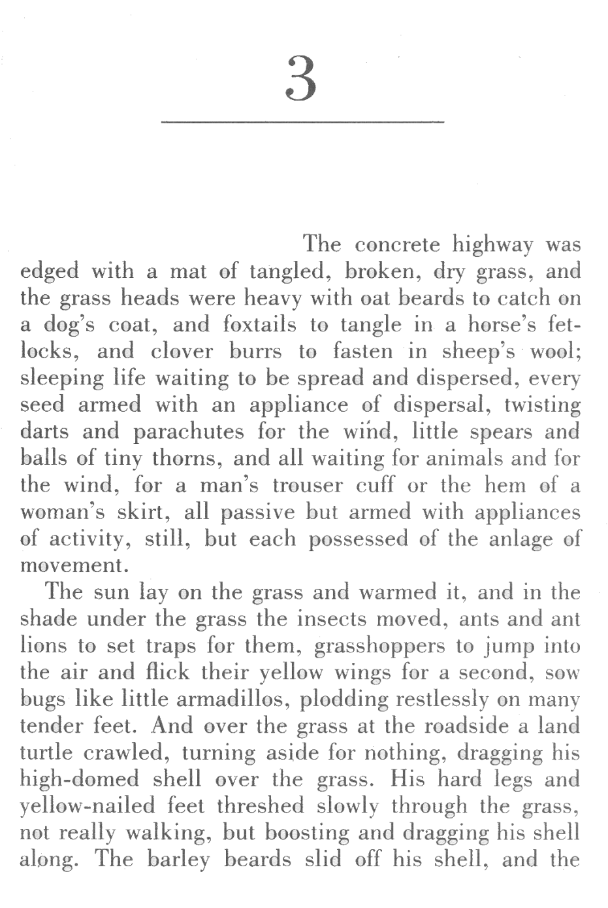
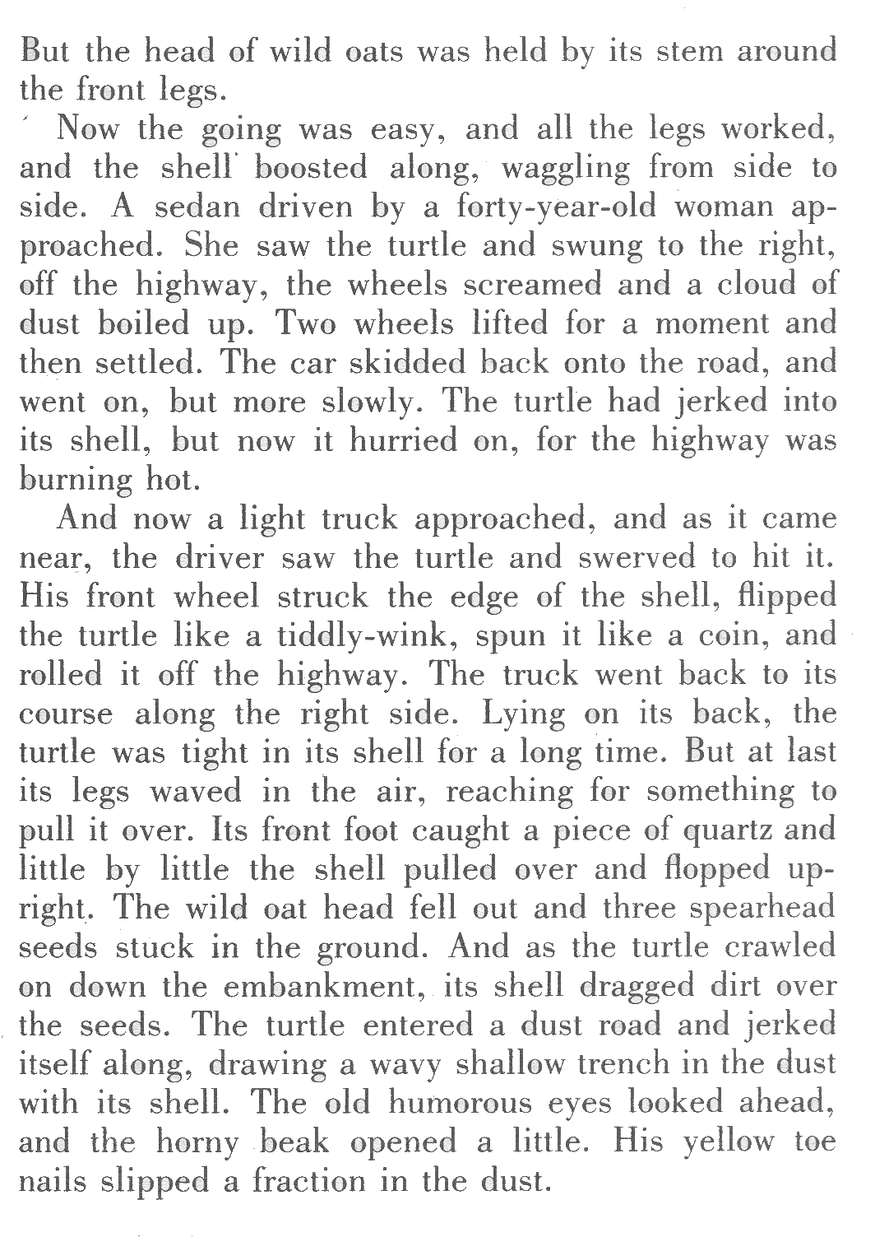
On a sheet of loose-leaf, please answer the following questions in complete sentences. Please provide reasons for your answers to inferential and critical questions. /8

Literal Questions
1. What is the turtle’s response to the ant crawling into its shell?
2. Why does the turtle hurry across the road after almost being hit by the first vehicle?

Inferential Questions
3. Does the woman in the first vehicle want to hit the turtle? Why do you think so?
4. Does the turtle intend to plant the seeds? How can you tell?

Critical Question
5. Do you think the turtle shows determination or foolishness in his actions? Explain why you think so.
Steinbeck, John. The Grapes of Wrath.” New York: Penguin Books, 1939. Print.

