The Giver

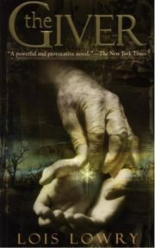
Create a movie poster that shows the themes, setting, and plot events that you think are important to the story. Use color and illustrations as well as words and phrases from the book to help you create an eye catching advertisement for the upcoming film.
Or
Create an alternate ending. Some people have said that they do not like the ending of this novel. Write an outline of an alternative ending that would better suit the novel as you see it. Your description of the ending should tie up loose details as all good endings do, but you do not need to write the chapter in its entirety. Identify the events and describe what will happen in the conclusion of the story in outline form no longer than 2 pages.
Or
Draw and label a map of your own perfect society. Include buildings and locations of key areas of interest that clearly show how your society functions in a utopian way. Label areas with explanations of government, security, how work and wealth is shared, healthcare, and education.
Assessment Criteria | Self Eval. | Mr. S' Eval.
Detail. All aspects of the project chosen are included clearly in the final product.
Evidence of examples and events from the novel are used to support the assignment. References may be direct or indirect.
Poster/map images are thoughtfully drawn and carefully chosen. Story outline identifies key themes and details from the plot narrative.
Assignment is carefully and neatly completed.
Spelling, punctuation, design, and layout effectively communicate a clear message that is understandable and attractive to its audience.
 | Total: | /10

