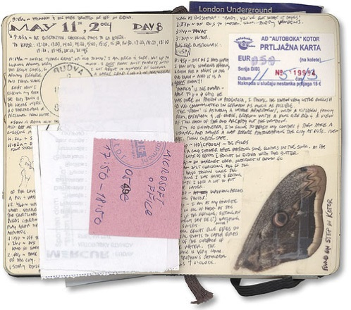
The Travel Journal of David
A travel journal is a personal space for reflection and recording of special events one experiences on the road. David has begun a great personal adventure and is constantly making observations about his surroundings. Your task is to create a journal and record David’s thoughts, observations, and opinions at various stages in his journey. You will be given 5 entry prompts at different times during our reading. Answer each prompt as though you are David writing in your journal.
Criteria | 5 | 4 | 3 | 2-1
David’s perspective | Journal accurately reflects David’s thoughts and feelings regarding the events described in the journal prompt. David’s point of view is clear and skillfully created. | David’s thoughts and feelings are logical and connected to the events described in the prompt. David’s point of view is often clear and accurate. | David’s voice is present in the journal entry with minor variation in tone. David’s ideas and feelings are shown. | The voice of the entry is not consistent with the character of David.
Mechanics | Spelling, punctuation, and correct and varied sentence structure is maintained throughout the response. Response length is sufficient. Language is precise and descriptive | Spelling, punctuation, and correct and varied sentence structure is usually maintained throughout the response. Response length is sufficient. Language is often precise and descriptive. | Spelling, punctuation, and correct and varied sentence structure shows occasional errors that do interfere with understanding. Response length may be limited. Some word choice shows careful selection. | Mechanical errors impede meaning. Frequent sentence errors require further revision. Response length may not be enough to meet the reading prompt goal.
Aesthetics | Exceptional care and effort are shown in layout. Pages are neat and include detailed illustrations where prompted. | Care and effort are shown in layout. Pages are often neat and illustrations are included. | Satisfactory care and effort are shown in layout. Pages are organized and legible. Some illustrations present. | Book and entries show little attempt to illustrate and organize in an attractive way.

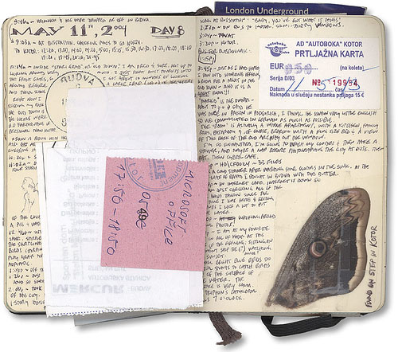
The Travel Journal of David
A travel journal is a personal space for reflection and recording of special events one experiences on the road. David has begun a great personal adventure and is constantly making observations about his surroundings. Your task is to create a journal and record David’s thoughts, observations, and opinions at various stages in his journey. You will be given 5 entry prompts at different times during our reading. Answer each prompt as though you are David writing in your journal.
Criteria | 5 | 4 | 3 | 2-1
David’s perspective | Journal accurately reflects David’s thoughts and feelings regarding the events described in the journal prompt. David’s point of view is clear and skillfully created. | David’s thoughts and feelings are logical and connected to the events described in the prompt. David’s point of view is often clear and accurate. | David’s voice is present in the journal entry with minor variation in tone. David’s ideas and feelings are shown. | The voice of the entry is not consistent with the character of David.
Mechanics | Spelling, punctuation, and correct and varied sentence structure is maintained throughout the response. Response length is sufficient. Language is precise and descriptive | Spelling, punctuation, and correct and varied sentence structure is usually maintained throughout the response. Response length is sufficient. Language is often precise and descriptive. | Spelling, punctuation, and correct and varied sentence structure shows occasional errors that do interfere with understanding. Response length may be limited. Some word choice shows careful selection. | Mechanical errors impede meaning. Frequent sentence errors require further revision. Response length may not be enough to meet the reading prompt goal.
Aesthetics | Exceptional care and effort are shown in layout. Pages are neat and include detailed illustrations where prompted. | Care and effort are shown in layout. Pages are often neat and illustrations are included. | Satisfactory care and effort are shown in layout. Pages are organized and legible. Some illustrations present. | Book and entries show little attempt to illustrate and organize in an attractive way.

